SQL Queries

First Querie:

SELECT Customer.First_Name,Customer.Last_Name,Customer.E_Mail,Booking.Price,Booking.Pick_up_date

FROM Customer

INNER JOIN Booking on Booking.Customer_ID=Customer.Customer_ID;

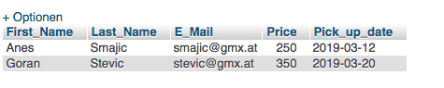

Second Querie:

SELECT Customer.First_Name,Customer.Last_Name,Customer.E_Mail,Booking.Price,Booking.Pick_up_date,Company.Company_Name,Company.Parking_Space

FROM Customer

INNER JOIN Booking ON Booking.Customer_ID=Customer.Customer_ID

INNER JOIN Company ON Company.Company_ID= Booking.Company_ID;

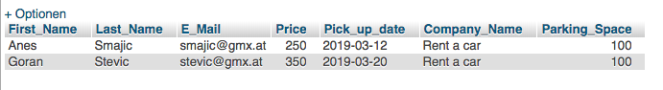

Third Querie:

SELECT Customer.First_Name,Customer.Last_Name,Customer.E_Mail,Booking.Price,Booking.Pick_up_date,Company.Company_Name,Company.Parking_Space,Manufacturer.Manufacturer_Name

FROM Customer

INNER JOIN Booking ON Booking.Customer_ID=Customer.Customer_ID

INNER JOIN Company ON Company.Company_ID= Booking.Company_ID

INNER JOIN Manufacturer ON Manufacturer.Manufacturer_ID=Company.Manufacturer_ID;

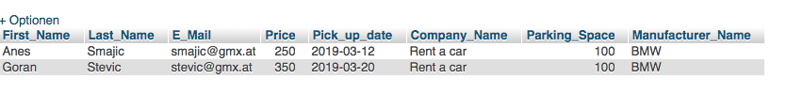

All Queries:

SELECT Customer.First_Name,Customer.Last_Name,Customer.E_Mail,Destinantion.Location,Booking.Price,Booking.Pick_up_date,Company.Company_Name,Company.Parking_Space,

Manufacturer.Manufacturer_Name,Vehicle.Model,VehicleAvailable.Available_date,BreakdownService.Service_Name,BreakdownService.Employee_Name,BreakdownService.Damage_Report

FROM Customer

INNER JOIN Destinantion ON Destinantion.Destination_ID=Customer.Destination_ID

INNER JOIN Booking ON Booking.Customer_ID=Customer.Customer_ID

INNER JOIN Company ON Company.Company_ID= Booking.Company_ID

INNER JOIN Manufacturer ON Manufacturer.Manufacturer_ID=Company.Manufacturer_ID

INNER JOIN Vehicle ON Vehicle.Manufacturer_ID= Manufacturer.Manufacturer_ID

INNER JOIN VehicleAvailable ON VehicleAvailable.Available_ID=Vehicle.Available_ID

INNER JOIN BreakdownService ON BreakdownService.Service_ID=Vehicle.Service_ID;

